Aim

Write a program to perform the deletion of white spaces such as horizontal tab, vertical tab, space, line feed, new line and carriage return from a text file and store the contents of the file without the white spaces on another file.

Experiment - 27

Object Oriented Programming Lab

Syeda Reeha Quasar

14114802719

4C7

# **EXPERIMENT – 27**

## **Aim:**

Write a program to perform the deletion of white spaces such as horizontal tab, vertical tab, space, line feed, new line and carriage return from a text file and store the contents of the file without the white spaces on another file.

## **Source Code:**

#include <fstream>

#include <iostream>

using namespace std;

int main()

{

    char data[100];

    // open a file in write mode.

    ofstream outfile;

    outfile.open("afile.txt");

    cout << "Writing to the file" << endl;

    cout << "Enter your name: ";

    cin.getline(data, 100);

    // write inputted data into the file.

    outfile << data << endl;

    cout << "Enter your age: ";

    cin >> data;

    cin.ignore();

    // again write inputted data into the file.

    outfile << data << endl;

    // close the opened file.

    outfile.close();

    // open a file in read mode.

    ifstream infile;

    infile.open("afile.txt");

    cout << "Reading from the file" << endl;

    infile >> data;

    // write the data at the screen.

    cout << data;

    infile >> data;

    cout << data;

    infile >> data;

    cout << data << endl;

    // again read the data from the file and display it.

    infile >> data;

    cout << data << endl;

    // close the opened file.

    infile.close();

    char fname1[10], fname2[10];

    char ch;

    cout << "enter a file name to be copied ?\n";

    cin >> fname1;

    cout << "new file name ? \n";

    cin >> fname2;

    infile.open(fname1);

    if (infile.fail())

    {

        cerr << "No such a file exists \n";

        exit(1);

    }

    outfile.open(fname2);

    if (outfile.fail())

    {

        cerr <<"unable to create a file \n";

        exit(1);

    }

    while (!infile.eof())

    {

        ch = (char)infile.get();

        if (ch == ' ' || ch == '\t' || ch == '\n');

        else

            outfile.put(ch);

    }

    // close the opened file.

    infile.close();

    // close the opened file.

    outfile.close();

    return 0;

}

## **Output:**

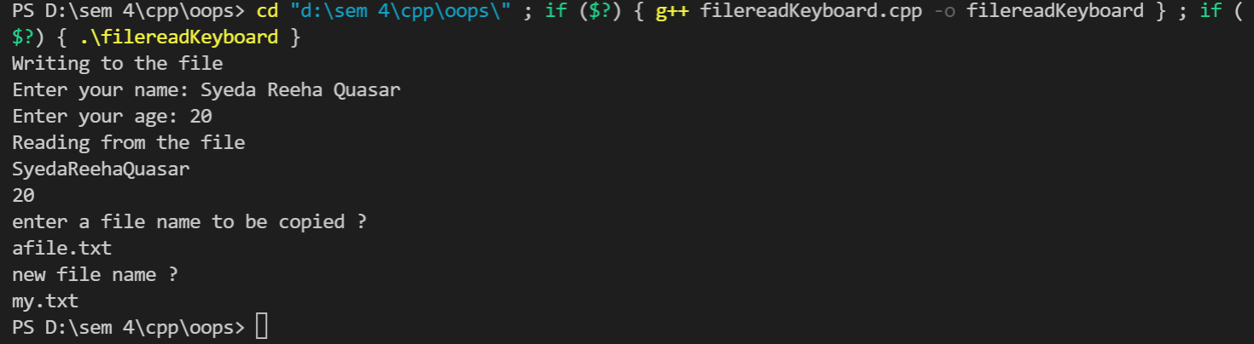

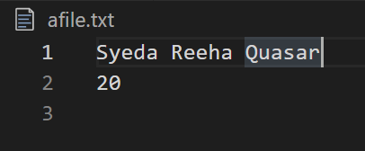

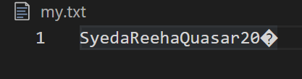

# **Viva Questions**

**Q1). What is file handling in C++?**

Files store data permanently in a storage device. With file handling, the output from a program can be stored in a file. Various operations can be performed on the data while in the file.

A stream is an abstraction of a device where input/output operations are performed. You can represent a stream as either a destination or a source of characters of indefinite length.

**Q2). What is fstream Library?**

Ans.

The fstream library provides C++ programmers with three classes for working with files. These classes include:

* **ofstream**- This class represents an output stream. It's used for creating files and writing information to files.
* **ifstream**- This class represents an input stream. It's used for reading information from data files.
* **fstream**- This class generally represents a file stream. It comes with ofstream/ifstream capabilities. This means it's capable of creating files, writing to files, reading from data files.

The following image makes it simple to understand:

[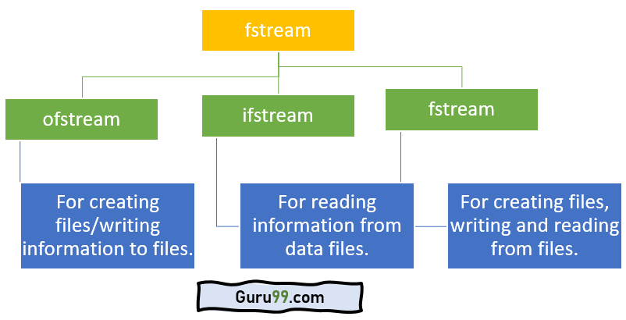](https://www.guru99.com/images/2/100520_1107_CFileHandli1.png)fstream library

To use the above classes of the fstream library, you must include it in your program as a header file. Of course, you will use the #include preprocessor directive. You must also include the iostream header file.

**Q3). What are benefits of file handing?**

Ans.

* With file handling, the output of a program can be sent and stored in a file.
* A number of operations can then be applied to the data while in the file.
* A stream is an abstraction that represents a device where input/output operations are performed.
* A stream can be represented as either destination or source of characters of indefinite length.
* The fstream library provides C++ programmers with methods for file handling.
* To use the library, you must include it in your program using the #include preprocessor directive.